**Issue #17 - Making A Program Name Mandatory**

To complete this task I started by going to the PPRstat-sandbox and selecting Data (which will automatically open when you click on this page)

Then I selected **Program** under **Objects** (all highlighted in image 1)

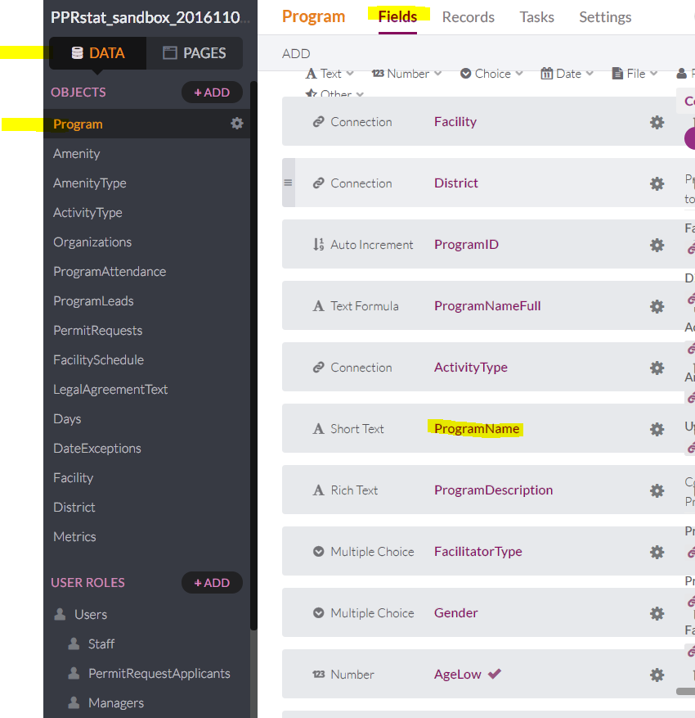 *image 1*

This will take you to the **Fields** screen where you will see ProgramName

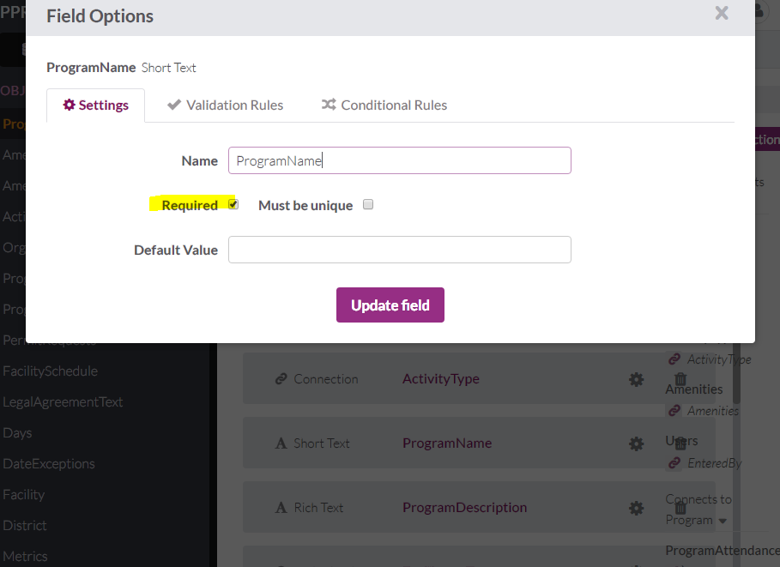 *image 2*

Once you click ProgramName you will be prompted with the following screen where you will select Required in the check box.